

Mini Project Report - 03

Master of Computer Application – General
Semester – I

Sub: Frontend Frameworks and Technologies

Topic: Student Registration Form
By
Name: Ashraj Singh Rana
Reg no.: PROV/ASAC/MCA/7/26/058

Faculty Name: VEERA RAGHAV K

Faculty Signature: _______________

Department of Computer Application
Alliance University
Chandapura - Anekal Main Road, Anekal
Bengaluru - 562 106
August 2025

INDEX
Fig No. | Name of table | Page No.
1. | INTRODUCTION | 1
2. | INPUT CODE | 2 - 10
3. | OUTPUT CODE | 11
4. | CONCLUSION | 12

INTRODUCTION
The Student Registration Form is a web-based front-end project developed using HTML to collect and organize student information in a structured and user-friendly format. The form contains different sections such as Student Information, Contact Information, Academic Information, Address Details, and Resume/Document Upload. Various HTML form elements including text fields, number fields, date inputs, dropdown menus, textarea, file upload, submit and reset buttons are used to collect the required details. HTML validation attributes such as required, minlength, maxlength, pattern, type, and accept are also implemented to ensure that users enter information in the correct format. The project demonstrates the practical use of HTML forms and input elements for developing an organized and interactive student registration interface.

INPUT CODE
<!DOCTYPE html>
<html lang="en">

<head>
<meta charset="UTF-8">
<meta name="viewport" content="width=device-width, initial-scale=1.0">
<title>Student Registration Form</title>

<style>
* {
box-sizing: border-box;
}

body {
min-height: 100vh;
margin: 0;
padding: 2rem 1rem;
background: #f3e9dc;
color: #4a3428;
font-family: "Segoe UI", Tahoma, sans-serif;
}

h1 {
text-align: center;
margin: 0 0 2rem;
background: #8b5e3c;
color: #ffffff;
padding: 1.25rem 1rem;
border-radius: 0.6rem;
font-size: clamp(1.35rem, 3vw, 1.9rem);
letter-spacing: 0.02em;
}

.form {
display: flex;
justify-content: center;
width: 100%;
}

form {
width: min(100%, 46rem);
padding: 2rem 2.5rem 2.5rem;
background: #fffaf4;
border: 1px solid #ddc8b5;
border-radius: 0.75rem;
box-shadow: 0 1rem 2.5rem rgba(91, 64, 48, 0.16);
}

label {
display: grid;
grid-template-columns: minmax(8rem, 0.8fr) minmax(0, 1.6fr);
gap: 1rem;
align-items: center;
margin-bottom: 1rem;
color: #5b4030;
font-size: 1rem;
font-weight: 600;
}

label br {
display: none;
}

input,
select,
textarea {
width: 100%;
min-width: 0;
padding: 0.7rem 0.8rem;
border: 1px solid #cbb39f;

border-radius: 0.4rem;
background: #fffdf9;
color: #4a3428;
font: inherit;
transition: border-color 0.2s ease, box-shadow 0.2s ease;
}

input,
select {
height: 2.7rem;
}

textarea {
min-height: 7rem;
resize: vertical;
}

input[type="file"] {
height: auto;
padding: 0.55rem 0.65rem;
background: #fffaf4;
}

input:focus,
select:focus,
textarea:focus {
outline: none;
border-color: #8b5e3c;
box-shadow: 0 0 0 3px rgba(139, 94, 60, 0.18);
}

.button {
display: flex;
justify-content: flex-end;
gap: 0.75rem;
margin-top: 1.5rem;
}

button {
min-width: 7rem;
height: 2.7rem;
padding: 0 1.25rem;
border: 1px solid transparent;
border-radius: 0.4rem;
color: #ffffff;
font: inherit;
font-weight: 600;
cursor: pointer;
transition: background-color 0.2s ease, transform 0.2s ease;
}

button:hover {
transform: translateY(-1px);
}

#submitBtn {
background-color: #8b5e3c;
}

#submitBtn:hover {
background-color: #6f452c;
}

#resetBtn {
background-color: #a88972;
}

#resetBtn:hover {
background-color: #826650;
}

@media (max-width: 600px) {
body {
padding: 1rem 0.75rem;
}

form {
padding: 1.25rem 1rem 1.5rem;
}

label {
grid-template-columns: 1fr;
gap: 0.4rem;
margin-bottom: 1rem;
}

.button {
justify-content: stretch;
}

button {
flex: 1;
}
}
</style>
</head>

<body>

<div class="form">

<form>
<h1>Student Registration Form</h1>
<label>Registration ID:
<input type="text" id="regId" name="regId" required><br><br>
</label>

<label>Name:
<input type="text" id="name" name="name" required><br><br>
</label>

<label>Gender:

<select id="gender" name="gender" required>
<option value="">Select</option>
<option value="male">Male</option>
<option value="female">Female</option>
</select><br><br>
</label>

<label>Date of Birth:
<input type="date" id="dob" required><br><br>
</label>

<label>Email:
<input type="email" id="email" required><br><br>
</label>

<label>Phone Number:
<input type="tel" id="phone" required><br><br>
</label>

<label>Department:
<input type="text" id="department" required><br><br>
</label>

<label>Course:
<input type="text" id="course" required><br><br>
</label>

<label>Section:
<input type="text" id="section" required><br><br>
</label>

<label>College:
<input type="text" id="college" required><br><br>
</label>

<label>Address:
<textarea id="address" name="address" rows="4" cols="50" required></textarea><br><br>
</label>

<label>Upload Resume:
<input type="file" id="resume" accept=".pdf,.doc,.docx" required><br><br>
</label>

<div class="button">
<button id="submitBtn" type="submit" value="Submit">Submit</button>
<button id="resetBtn" type="reset" value="reset">Reset</button>
</div>
</form>
</div>

OUTPUT
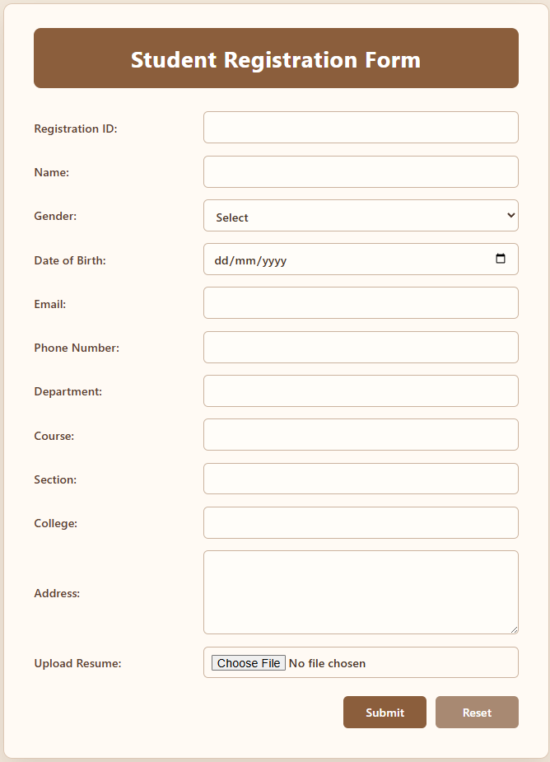
CONCLUSION

The Student Registration Form successfully demonstrates the implementation of HTML form elements to create a structured and user-friendly registration interface. The form efficiently organizes student, contact, academic, address, and document-related information into separate sections. HTML validation features help ensure that important fields are completed and that information such as email addresses and phone numbers follows the required format. The Submit and Reset buttons provide basic form interaction for users. Overall, this project provides practical experience in creating web forms, organizing content, and applying HTML input validation techniques for a real-world student registration system.

